投影程序更改单
Projection Program Change Sheet

编号  Serial No. | (1) |  |  |  |  | 单位  Shop. |  | (2)
项目代号  Project | (3) |  |  |  |  | 日期  Date |  | (4)
更改前程序名  Past Program No. |  |  | 更改后程序名  Current Program No. |  |  | 更改前内容  Past Content |  |  |  | 更改后内容  Current Content
(5) |  |  | (6) |  |  | (7) |  |  |  | (8)
更改原因：
Reason for Change: (9)
编程员  Programmer | (10) | 校对 Checked |  | (11) | 检验员  Inspector |  | (12) |  | 批 准  Approved by |  | (13)

填写说明Instructions for Filling：
（1）生产厂工艺员填写投影程序鉴定表编号，编号的组成结构如下图，投影程序更改单（FM1406-22）文件类别代码为PG；如“S5C-PG9400-022”。
The technologist of the manufacturer shall fill in the number of projection program identification form. The composition of the number is shown in the figure below. The document category code of projection program change sheet (FM1406-22) is PG; Such as "S5C-PH9400-022".
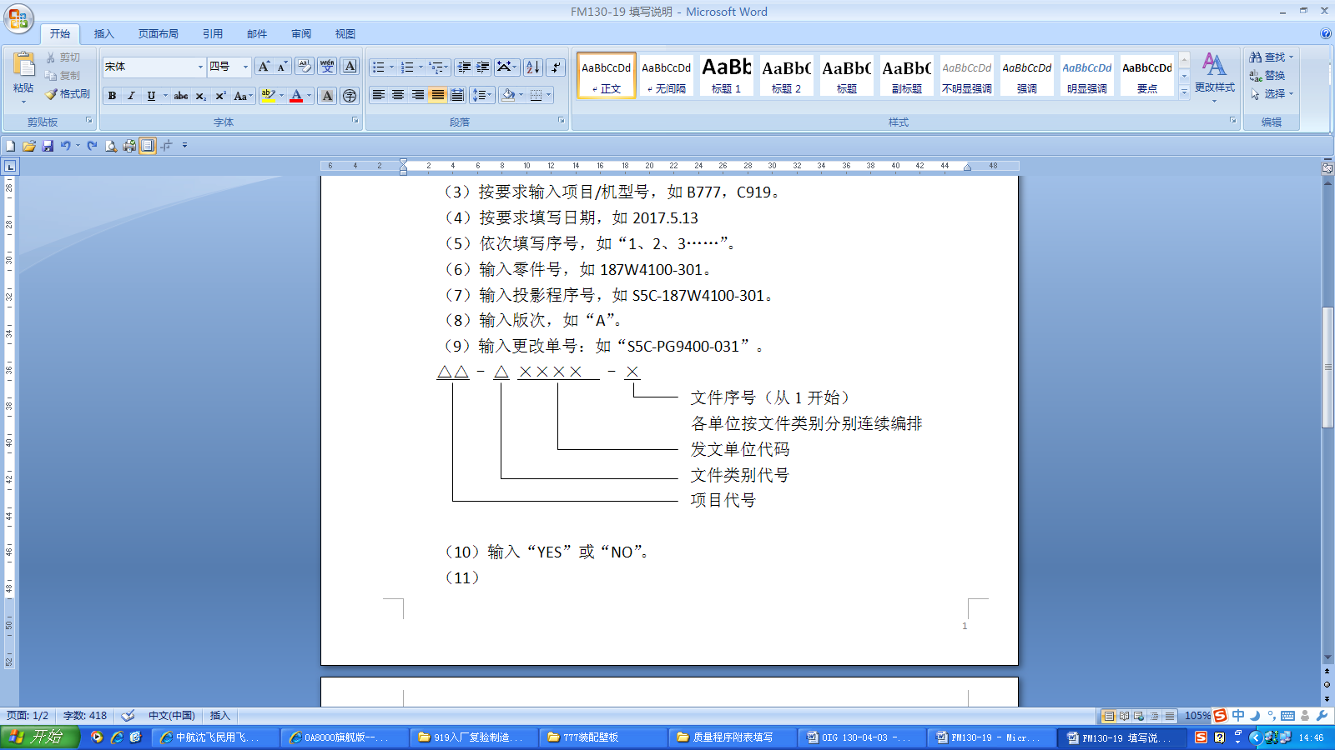
Text serial number (starting from 1)
Each unit shall be arranged consecutively according to document type
Code of issuing unit
Document category code
Project code

（2）生产厂工艺员填写单位名称，如“零件制造中心”。
The planner of the manufacturer fills in the unit name, such as "Parts Manufacturing Center".
（3）生产厂工艺员填写项目代号。
The planner of the manufacturer fills in the project code.
（4）生产厂工艺员填写投影程序更改日期，如2017.5.13。
The planner of the manufacturer fills in the change date of projection program, such as 2017.5.13.
（5）生产厂工艺员填写更改前程序名，如“S5C-187W4300-301-A”。
The planner of the manufacturer fills in the name of the change process, such as "S5C-187W4300-301-A".
（6）生产厂工艺员填写更改后程序名，如“S5C-187W4300-301-B”。
The planner of the manufacturer fills in the changed program name, such as "S5C-187W4300-301-B".
（7）生产厂工艺员填写更改前内容。
The planner of the manufacturer fills in the contents before the change.
（8）生产厂工艺员填写更改后内容。
The planner of the manufacturer fills in the changed contents.
（9）生产厂工艺员填写更改原因，如：“设计更改、工艺状态更改”。
The planner of the manufacturer shall fill in the reason for change, such as "design change, process status change".
（10）内容由生产厂工艺员签字。
The content shall be signed by The planner of the manufacturer.
（11）内容由生产厂技术室主任签字校对。
The contents shall be signed and proofread by the director of the technical office of the manufacturer.
（12）内容由生产厂检验员签字。
The content shall be signed by the inspector of the manufacturer.
（13）内容由生产厂技术副厂长签字批准。
The content shall be signed and approved by the technical deputy director of the manufacturer.

